CS 3320

Bryn Webb

Image Compression Project

Introduction:

This project requires the compression of two photographs into a good photograph and a useable photograph. For this project, I consider a good photograph to be one without any discernable artifacts when displayed on a full computer screen. A usable photograph will be one with a minimal number of artifacts. One where everything is identifiable, but there may be small evidence of compression.

As I adjusted the p value, I noticed that the higher the p value, the more distortion there was of the images. As p got very large, the colors changed dramatically, and eventually very little of the image was visible.

The first picture I used was of a sign. As p got larger I started noticing that the brown paint on the sign started to look shiny, and then the background started looking pixelated. Eventually the edges of the sign blurred as well. For a good photograph I set p equal to 6. I couldn’t easily spot any distortions at that point. For a useable image I set p = 13. There I could notice a bit of discoloration of the sign, but it was still easy to tell what everything was, and the distortions were minor.

My second image was of a field of orange flowers. On this the first things I noticed as I adjusted the value of p were pixelation and blurred colors on the leaves in the background. Then the flowers in the lower left side of the picture began to look blocky. Once again I found that setting p to 6 allowed for a good picture, without any visible defects. And for a usable picture I set p equal to 12, with a small amount of distortion in the background leaves and the out of focus flowers.

Original Image 1



Good image 1



Usable image 1



Original Image 2

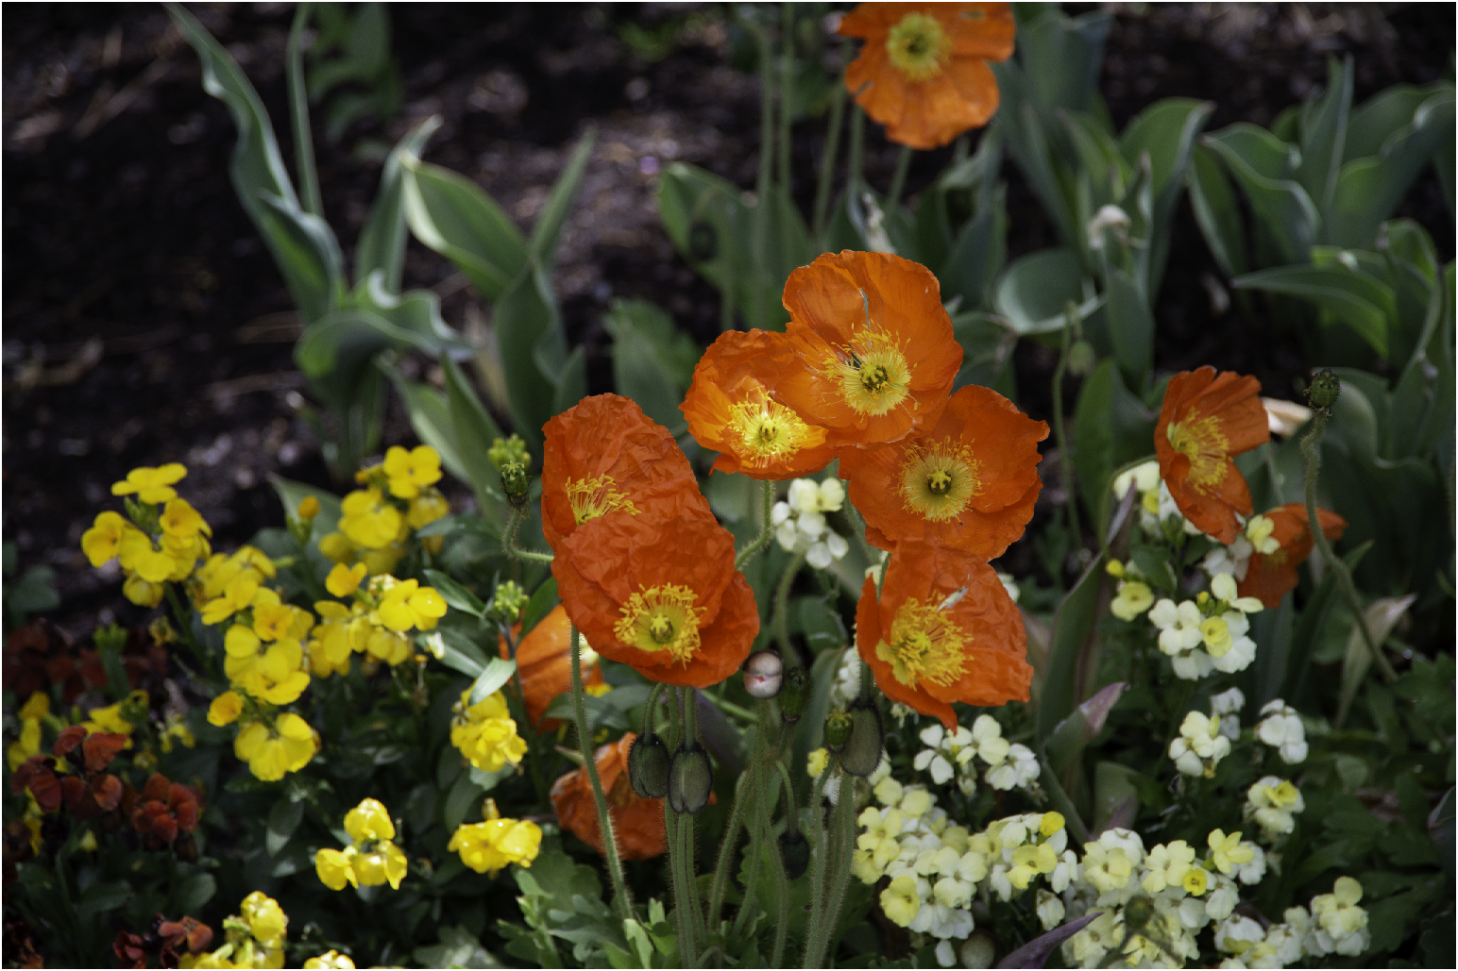

Good image 2

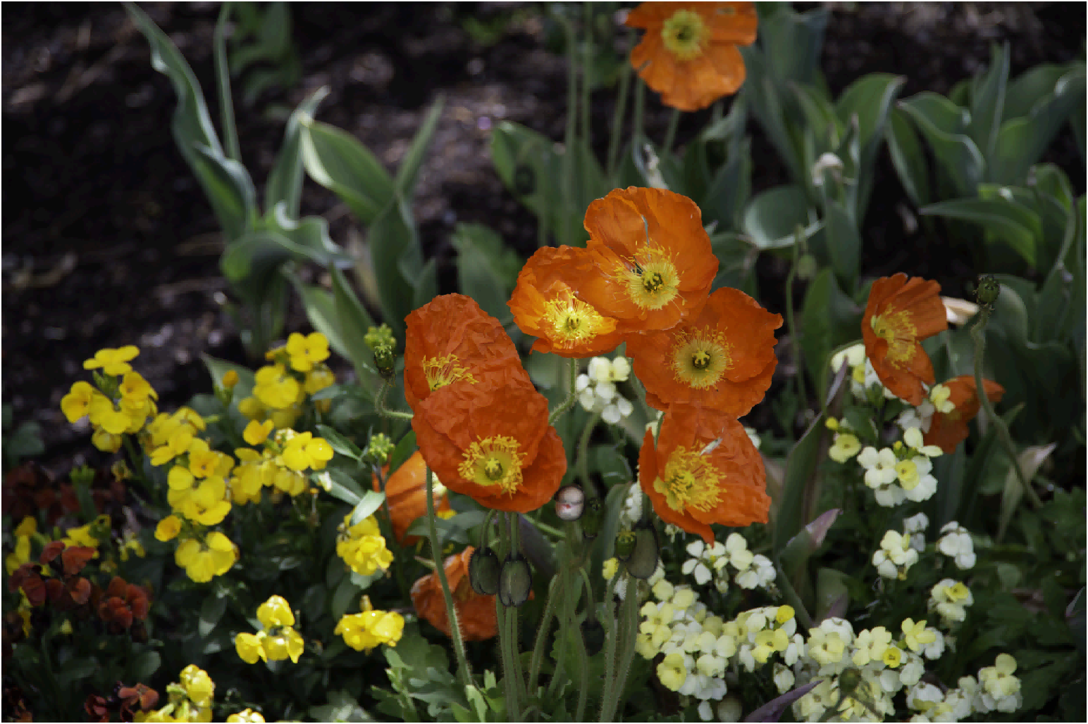

Usable image 2

